Dear friends,

We are so excited to host a supply drive to help save local wildlife!

This drive will benefit local 501(C)3 nonprofit, Second Chances Wildlife Center. Second Chances rehabilitates over 300 animals each year and provides lifetime sanctuary for over 45 animals! Some of these animals were confiscated from neglect and hoarding situations, some rescued from the pet trade and fur farms while others could not quite survive on their own in the wild. These animals get licensed under the USDA for education. They help teach people about respecting wildlife, their niches in our ecosystem, and the importance of biodiversity. They foster a desire for students to be good stewards of our environment.

Second Chances depends on our community support to be able to offer their unique and important services to all of us. Through our supply drive, you are helping to save our local wildlife that need us! Many animals need to be rehabilitated due to human encroachments such as being hit by cars, attacked by dogs and outdoor cats, exposed to pesticides, cut from trees, and injured from other lawn equipment. Let’s show them our kind hearts.

There is a wish list on Second Chances’ website. The QR code will take you there. The website is also listed below. Please return all items by (XXX DATE).

On behalf of ( XXX YOUR SCHOOL OR ORGANIZATION) and Second Chances Wildlife Center, we thank you in advance!

Sincerely,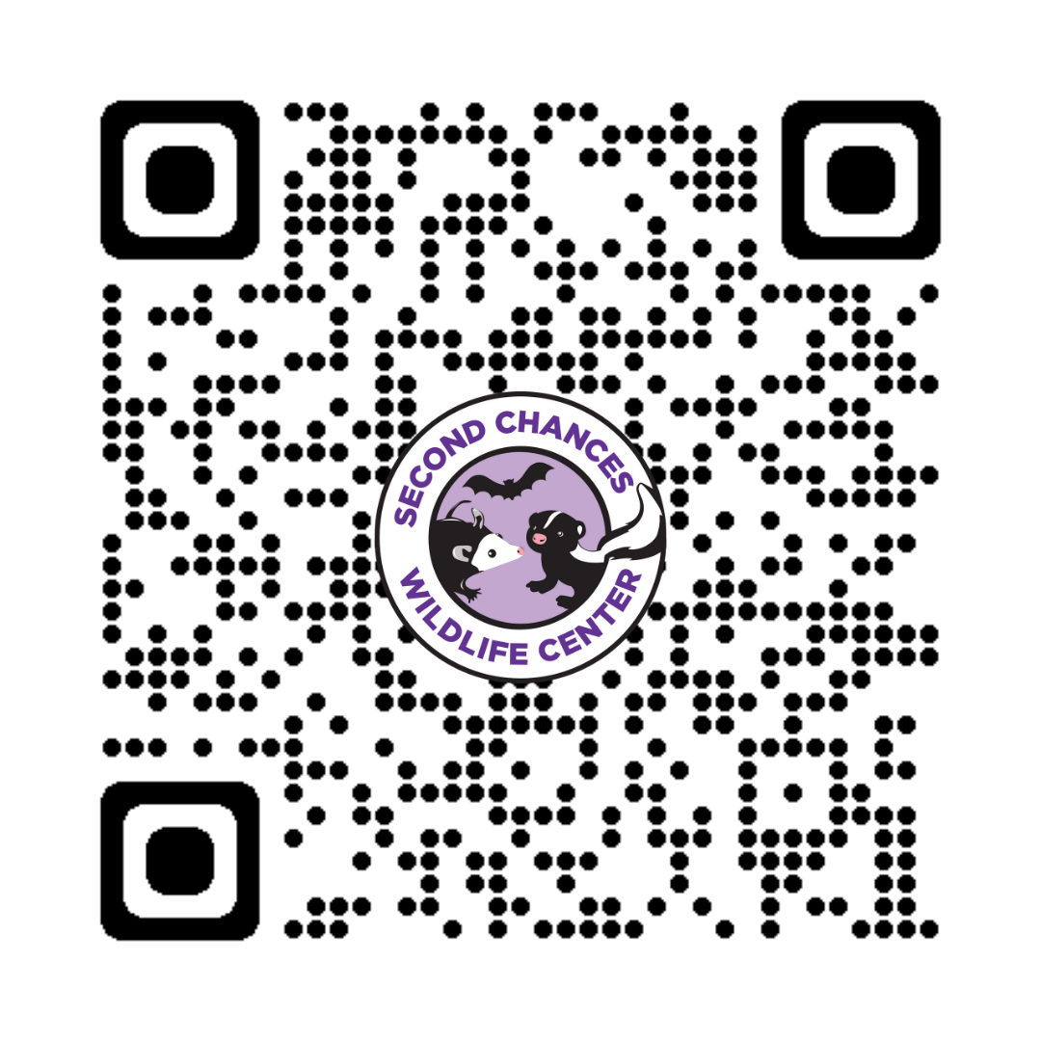

(XXX YOUR SIGNATURE)

**SecondChancesWildlife.org**